Epson GPC
RF Application

User Guide

Release Version | : | 2.0
Release Date | : | 11/05/2009

Revision History

Date | Document Version | Description | Author
16-Aug-06 | 1.0.0 | Initial Document | Chan Pei Fong
11-May-09 | 2.0.0 | New function Put-away Search  Migrate Put-away function from Exceed RF to Jupiter | Chan Pei Fong

Table of Contents

1. Overview 4
2. Application guide 4
2.1. RF Login 4
2.2. Main Menu 6
2.2.1. Cycle Count 6
2.2.2. Putaway-Search 7

Overview
Epson GPC has implemented Perpetual Cycle Count (PCC) work process as replacement of the stock take. Operations will conduct the cycle count by selected aisle / sections.
RF Cycle Count is a supported function to existing Hub-WMS PCC Entry module. It allows users to enter physical count quantity direct to WMS using RF scanner.
After the physical count completed, reconciliation occurs and discrepancies will be adjusted in the Exceed Adjustment screens.

Application guide

RF Login

    - Telnet NT login
First logon to Telnet session, enter user ID and Password.

User ID = gpcrfcc
Password = *******
Domain = baxsin

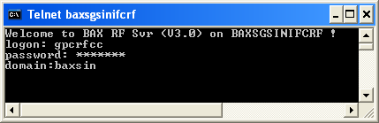

Welcome screen will appear on the screen as follow: 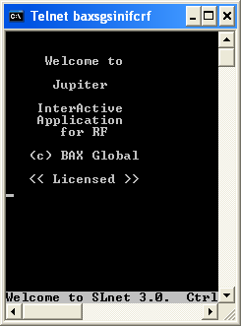

    - WMS login
Enter WMS user id and password.

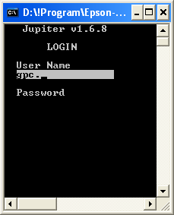

    - Database Selection:

Enter number: [0]

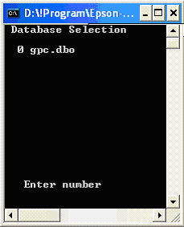

Main Menu

Cycle Count

    - Select Menu [Cycle Count]
Enter number [0]

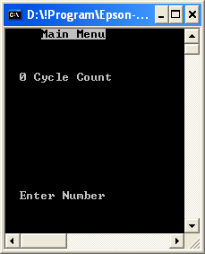

    - Cycle Count Menu will appear,
Sample:
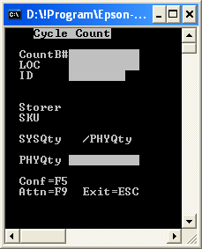 | 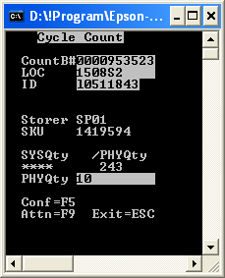  Total counted qty

    - Scan Count Book number
[CountB#]
    - Scan Loc
    - Scan ID
    - SKU will be shown, press [Enter] to confirm.
    - Enter Count quantity, press [Enter]
    - Repeat Step No. 4 to continue count.
    - END.

Putaway-Search

- Select Menu [Putaway-Search]

Enter number: [2]
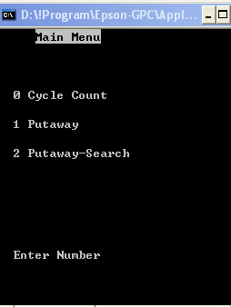

- Putaway-Search Screen appear as below:
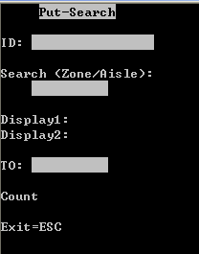 | Sample input:  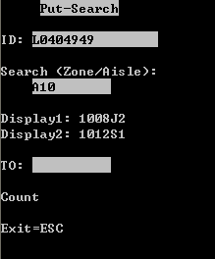

  - Scan ID: (LP #)
  - Enter Search key in format ZONE+Aisle
Eg. A10
  - System will display next available locations,
Sorted by row and level
  - Scan To location at “TO:” column.
  - System will confirm the putaway location.
  - Count = display number of performed put-away process.
  - Press “ESC” to return to Main Menu.

